|  |  |
| --- | --- |
| Internship Project Title | RIO-125: Automate Sentiment Analysis of Textual Comments and Feedbacks |
| Name of the Company | TCS iON |
| Name of the Industry Mentor | Mr. Debashis Roy |
| Name of the Institute | Vishwakarma University, Pune |

|  |  |  |  |  |
| --- | --- | --- | --- | --- |
| Start Date | End Date | Total Effort (hrs.) | Project  Environment | Tools used |
| 19/03/2024 | 25/04/2024 | 125 | Python | Jupyter Notebook – Pandas,  NLTK (Natural Language Toolkit),  TextBlob, Scikit-learn,  Matplotlib, Seaborn,  GridSearchCV, StandardScaler,  Pipeline, CountVectorizer,  Tokenizer, Sequential  Embedding, LSTM (Long ShortTerm Memory), Dense, SpatialDropout1D, EarlyStopping, etc. |

**TABLE OF CONTENT**

* Acknowledgements
* Objective
* Introduction / Description of Internship
* Internship Activities
* Approach / Methodology
* Assumptions
* Exceptions / Exclusions
* Charts, Table, Diagrams
* Algorithms
* Challenges & Opportunities
* Risk Vs Reward
* Reflections on the Internship
* Recommendations
* Outcome / Conclusion
* Enhancement Scope
* Link to code and executable file
* Research questions and responses

# ACKNOWLEDGEMENT

I'm truly grateful for the unwavering support and guidance extended to me throughout my project, RIO-125: Automate Sentiment Analysis of Textual Comments and Feedbacks. I want to express my heartfelt appreciation to my industry mentor, Mr. Debashis Roy from TCSiON, and my academic mentor, Dr. Mahfooz Alam from Vishwakarma University. Their constant motivation played a pivotal role in my journey.

Additionally, I extend my sincere thanks to TCS-iON and Vishwakarma University for granting me this invaluable opportunity, which has enriched my understanding of the industry landscape. I want to emphasize that I completed the project independently, without any external assistance.

# OBJECTIVE

To develop advanced deep learning algorithms aimed at accurately detecting various types of sentiments expressed within English sentences or lengthy paragraphs, with the ultimate goal of precisely predicting the overall sentiment conveyed by the entire text.

# INTRODUCTION/DESCRIPTION OF THE INTERNSHIP

Embarking on an exhilarating journey, this internship dives into the realm of teaching computers to decipher emotions from written text. Using the Flipkart customer reviews dataset, we'll delve into deep learning techniques, empowering computers to discern sentiments like happiness, sadness, and more nuanced emotions. Our aim is to equip our digital counterparts with the superpower to accurately interpret the emotional tone of any text, be it a brief message or a lengthy essay. Through this venture, we aim to enhance our computer companions'

understanding of human emotions, capturing the diverse range of sentiments expressed in written language.

# INTERNSHIP ACTIVITIES

The internship activities include the following:

1. Research and study sentiment analysis and deep learning algorithms. 2. Collect diverse textual data, preprocess it, and prepare it for training.

1. Experiment with various deep learning architectures for sentiment analysis.
2. Train models, evaluate their performance, and iterate for improvement.
3. Explore hyperparameter tuning techniques for model optimization.
4. Validate models generalization ability with unseen data.
5. Document the process and prepare reports summarizing findings.

# APPROACH/METHODOLOGY

The following Approaches and Methodologies were used in the project:

1. **Text Preprocessing**:
   * Tokenization breaks down the text into individual words or tokens, making it easier to analyze.
   * Part-of-Speech (POS) Tagging assigns grammatical categories to each token, such as noun, verb, adjective, etc. This information can be useful for tasks like lemmatization.
   * Lemmatization reduces words to their base or dictionary form, ensuring consistency in the representation of words. For example, "running" becomes "run".
   * Removing punctuation and stop words helps eliminate noise from the text, focusing on words that carry more significant meaning.

1. **Sentiment Analysis**:
   * Sentiment analysis determines the sentiment expressed in a piece of text. In this case, TextBlob is used, which provides a polarity score indicating the sentiment (positive, negative, or neutral) of the text.
   * Based on the polarity score, sentiment labels are assigned to each review.

1. **Regression Analysis**:
   * Linear regression is a statistical method used to model the relationship between independent variables (sentiment polarity) and a dependent variable (product rating).
   * The model is trained to predict product ratings based on sentiment polarity scores.
   * GridSearchCV is employed to systematically search for the best hyperparameters for the linear regression model, enhancing its performance.

1. **Hyperparameter Tuning**:
   * Hyperparameters are parameters that control the learning process of a machine learning algorithm.
   * GridSearchCV exhaustively searches through a specified parameter grid to find the optimal hyperparameters.
   * In this case, the fit_intercept parameter of the linear regression model is optimized to improve its predictive capability.
2. **Training Multiple Models**:
   * Multiple linear regression models with different hyperparameters are trained to explore different configurations.
   * This approach allows for the comparison of model performances and the selection of the best-performing model based on evaluation metrics like MSE.

1. **Adding n-Grams**:
   * N-grams are contiguous sequences of n items from a given sample of text. In this case, unigrams (single words) and bigrams (pairs of adjacent words) are included.
   * CountVectorizer is used to convert text data into numerical feature vectors, considering both unigrams and bigrams.
   * The inclusion of n-grams expands the feature space, capturing more context from the text data and potentially improving the model's predictive capability.

1. **Deep Learning for Sentiment Analysis**:
   * Deep learning models, particularly recurrent neural networks (RNNs) like LSTM, are well-suited for sequential data like text.
   * The LSTM model learns patterns and dependencies in the sequence of words to predict sentiment labels.
   * The model is trained on pre-processed text data and evaluated based on classification accuracy.

1. **Enhancing Predictive Model**:
   * Combining LSTM and CNN models in an ensemble approach aims to leverage the strengths of both architectures.
   * LSTM excels at capturing long-term dependencies in sequential data, while CNN is effective at capturing local patterns through convolutional filters.
   * The ensemble model combines the outputs of both architectures, potentially improving sentiment prediction accuracy through complementary learning.

# ASSUMPTIONS

The project consists of following assumptions:

1. **Text Representation**: The sentiment analysis assumes that the sentiment of a review can be accurately inferred from the text content alone. It doesn't take into account other factors like user demographics or product features.
2. **Language**: The sentiment analysis assumes that the language used in the reviews is English, as the NLTK library and TextBlob are primarily designed for English text processing.
3. **Accuracy of Sentiment Polarity**: The accuracy of sentiment polarity scores generated by TextBlob is assumed to be acceptable for the task at hand. While TextBlob provides a convenient way to perform sentiment analysis, it might not capture nuances in sentiment as accurately as more sophisticated models trained on specific domains.
4. **Labelling of Sentiment**: The sentiment labels (positive, negative, neutral) assigned based on polarity scores are assumed to adequately represent the sentiment expressed in the reviews. However, there might be cases where the polarity score doesn't fully capture the sentiment conveyed by the text.
5. **Relationship Between Sentiment and Rating**: The assumption is that there exists a relationship between the sentiment expressed in a review and the corresponding product rating. Generally, positive sentiments are expected to correlate with higher ratings, while negative sentiments correlate with lower ratings.
6. **Quality of Data**: The assumption is that the dataset (flipkart.csv) contains relevant and representative customer reviews and corresponding ratings for analysis. The quality of the sentiment analysis and regression models depends heavily on the quality and diversity of the data.
7. **Validity of Preprocessing Steps**: The text preprocessing steps, including tokenization, POS tagging, lemmatization, punctuation removal, and stop words removal, are assumed to effectively clean and normalize the text data, enhancing the performance of subsequent analysis.
8. **Model Selection**: The choice of models (linear regression, LSTM, ensemble of LSTM and CNN) is assumed to be appropriate for the task of sentiment analysis and rating prediction based on customer reviews. However, the effectiveness of each model depends on factors like data quality, feature representation, and model complexity.
9. **Hyperparameter Tuning Impact**: The assumption is that hyperparameter tuning using techniques like GridSearchCV improves the performance of the linear regression model and enhances the accuracy of sentiment prediction and rating estimation.
10. **Evaluation Metrics**: Mean Squared Error (MSE) is assumed to be an appropriate evaluation metric for regression analysis, measuring the accuracy of predicted ratings compared to actual ratings. Similarly, accuracy is used as the evaluation metric for the deep learning models, measuring the percentage of correctly predicted sentiment labels.

# EXCEPTIONS/EXCLUSIONS

The project consists the following exceptions/exclusions:

1. **Sarcasm and Irony**: Sentiment analysis might struggle to accurately identify sarcasm or irony in text, as these nuances can be context-dependent and challenging to detect algorithmically. Reviews containing sarcasm or irony may not be interpreted correctly by sentiment analysis tools like TextBlob.
2. **Emojis and Emoticons**: Sentiment analysis typically focuses on textual content and may not consider emojis or emoticons in the analysis. Emojis can convey emotions that may not be captured solely by analyzing text, potentially leading to misinterpretation of sentiment.
3. **Subjectivity and Context**: Sentiment analysis algorithms often overlook the subjective nature of language and the importance of context in understanding sentiment. Certain phrases or expressions may carry different meanings depending on the context, leading to inaccuracies in sentiment analysis.
4. **Language Variations and Slangs**: Sentiment analysis models trained on standard English may struggle to interpret reviews written in informal language, dialects, or slang. Variations in language usage across different demographics or regions may introduce biases or inaccuracies in sentiment analysis results.
5. **Negation and Amplification**: Sentiment analysis tools may not effectively handle negation or amplification words and phrases, where the sentiment is reversed or intensified. For example, "not bad" might be interpreted as positive sentiment despite containing the word "not."
6. **Length and Complexity of Text**: Sentiment analysis algorithms may perform differently depending on the length and complexity of the text. Short, concise reviews may provide limited context for sentiment analysis, while longer, more detailed reviews may contain nuanced sentiments that require more sophisticated analysis techniques.
7. **Domain-Specific Language**: Sentiment analysis models trained on general text corpora may not generalize well to domain-specific language or terminology. Reviews related to specialized topics or industries may contain domain-specific terms or jargon that are not adequately captured by the sentiment analysis model.
8. **Cultural and Social Factors**: Sentiment analysis may overlook cultural or social factors that influence the interpretation of sentiment. Cultural nuances, societal norms, and demographic differences can impact the perception and expression of sentiment in text, making it challenging to develop universal sentiment analysis models.
9. **Data Imbalance**: The dataset used for sentiment analysis may suffer from class imbalance, where one sentiment class (e.g., positive) is significantly more prevalent than others (e.g., negative or neutral). Imbalanced data can skew the performance of sentiment analysis models and lead to biased results.
10. **External Factors**: Sentiment expressed in reviews may be influenced by external factors such as marketing campaigns, competitor actions, or current events. These external factors can introduce noise or confounding variables that affect the accuracy of sentiment analysis predictions.

# CHARTS, TABLE, DIAGRAMS

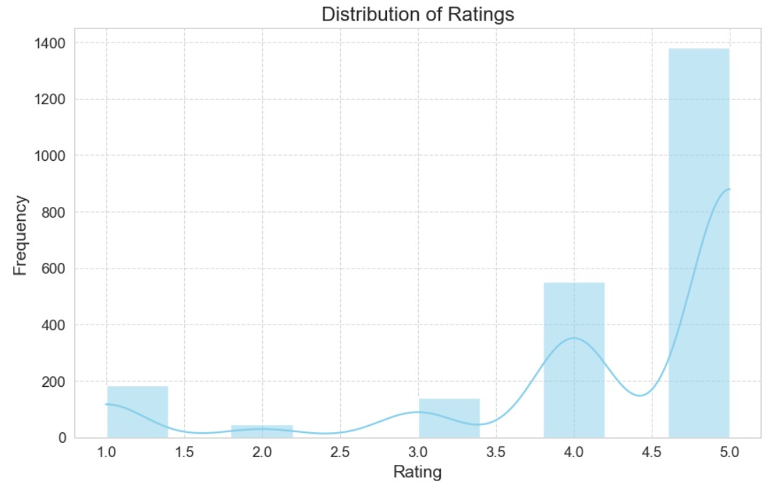

Histogram of customer ratings for various products on the online shopping platform "Flipkart." The graph displays ratings ranging from 1.0 to 5.0 on the x-axis and their corresponding frequencies on the y-axis. Notably, there is a scarcity of ratings between 1.0 and 3.5, with a slight increase noted at 3.0. Subsequently, there is a notable rise in frequency at 4.0, followed by a dip at 4.5, and a sharp peak at 5.0, indicating a significant clustering of ratings at the highest value.

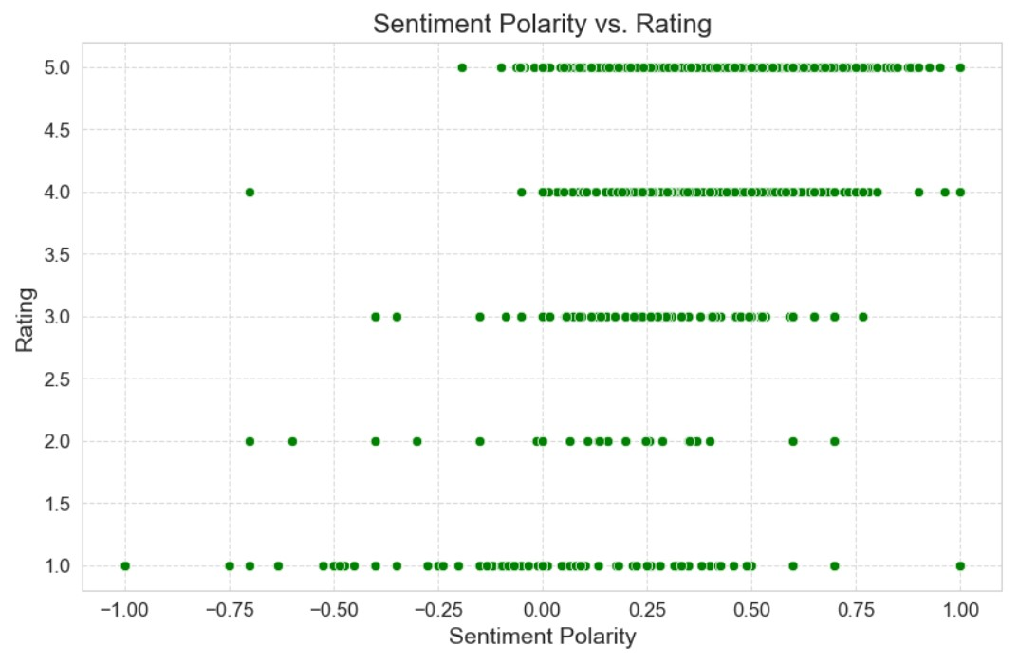

Scatter Plot titled "Sentiment Polarity vs. Rating" which illustrates the relationship between the sentiment polarity (ranging from -1.00 to 1.00) and the rating (ranging from 1.0 to 5.0). Green dots represent data points, indicating varying sentiment polarities and ratings. Data points cluster around integer rating levels, with denser concentrations near zero sentiment polarity. The highest concentration of points aligns with the top rating (5.0), predominantly displaying positive sentiment polarities. Lower ratings (1.0 to 2.0) exhibit fewer data points dispersed across both negative and positive sentiment polarities, suggesting a broader range of opinions when ratings are lower.

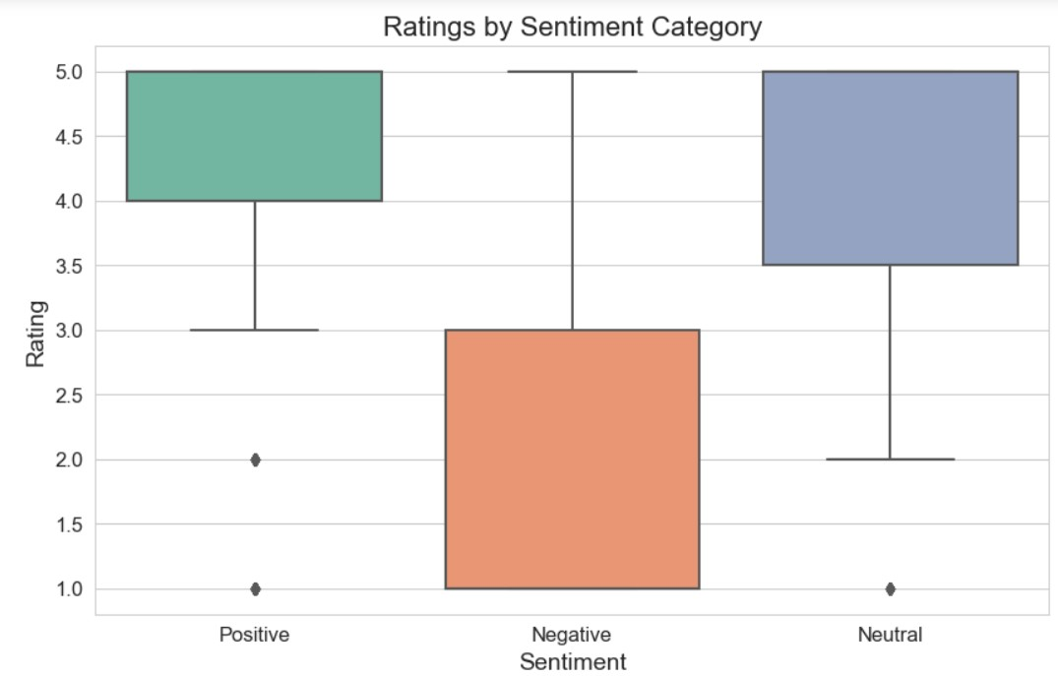

Boxplot titled "Ratings by Sentiment Category" which illustrates the average ratings assigned to Positive, Negative, and Neutral sentiment categories. Positive sentiment registers the highest average rating, followed by Neutral and Negative sentiments. Notably, outliers are visible within the Positive and Neutral categories, signifying substantial deviations from the average ratings within these groups.

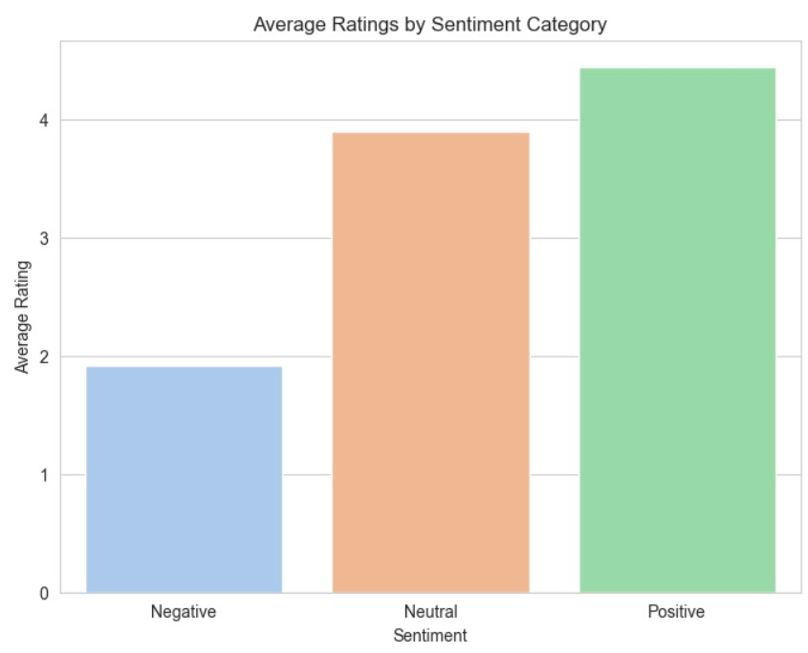

Vertical Bar Chart titled "Average Ratings by Sentiment Category," depicting the average customer sentiments categorized as Positive, Negative, or Neutral. The chart highlights that Positive sentiment garners the highest average rating, suggesting that customers are notably satisfied with the products or services. Following Positive sentiment, Neutral sentiments range between 3 and 4, indicating moderate satisfaction. Negative sentiments, ranging between 1 and 2, represent the lowest average ratings, suggesting dissatisfaction among customers.

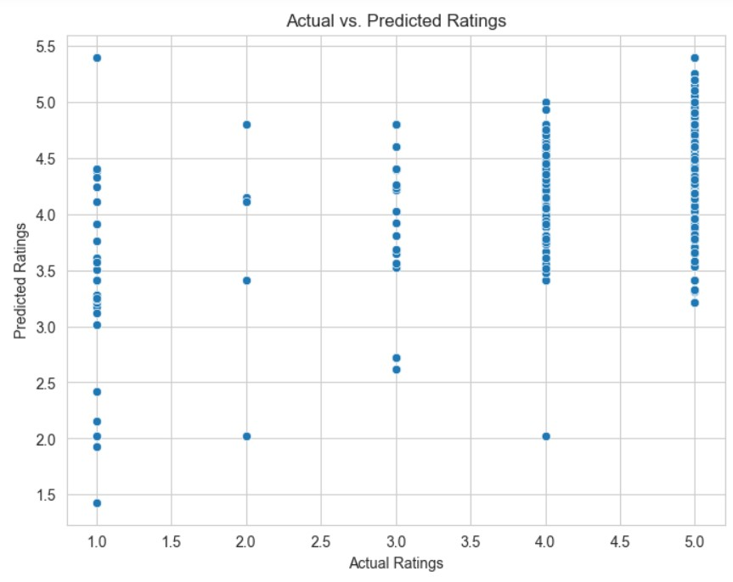

Scatterplot for "Actual Ratings" against "Predicted Ratings" using blue dots to denote individual data points. Actual ratings ranging from 1.0 to 5.0 are plotted on the x-axis, while predicted ratings are represented on the y-axis within the same range. Notably, for lower actual ratings, such as 1.0, the predicted ratings exhibit wide dispersion, ranging from 1.5 to over 5.0, indicating varying levels of accuracy in the prediction model. Conversely, as actual ratings increase, particularly for ratings of 4.0 and 5.0, predicted ratings cluster closer to the actual values with less variation. Overall, while the model demonstrates greater accuracy for higher actual ratings, it lacks consistency across all rating levels, suggesting room for improvement.

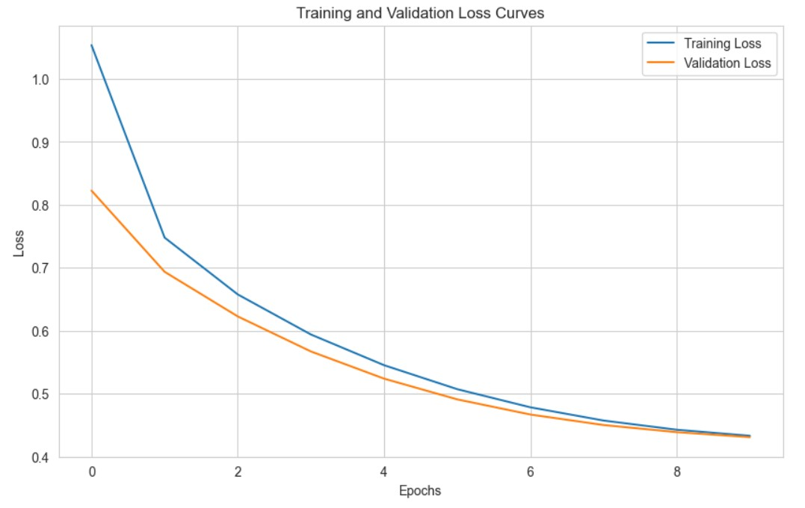

Line graph illustrating the "Training and Validation Loss Curves" of a machine learning model. The x-axis denotes "Epochs," spanning from 0 to over 8, while the y-axis represents "Loss," ranging from slightly above 0 to 1.0.

The blue line depicts "Training Loss," initially above 1.0, declining sharply with increasing epochs, and stabilizing around epoch 8. In contrast, the orange line, representing "Validation Loss," follows a similar decreasing trend but consistently remains higher than the training loss throughout the epochs.

Both losses demonstrate a decreasing trend over time, indicating learning within the model. However, the consistently higher validation loss compared to the training loss suggests potential overfitting, wherein the model performs well on the training data but struggles with unseen validation data, indicating the need for regularization techniques or adjustments to improve generalization.

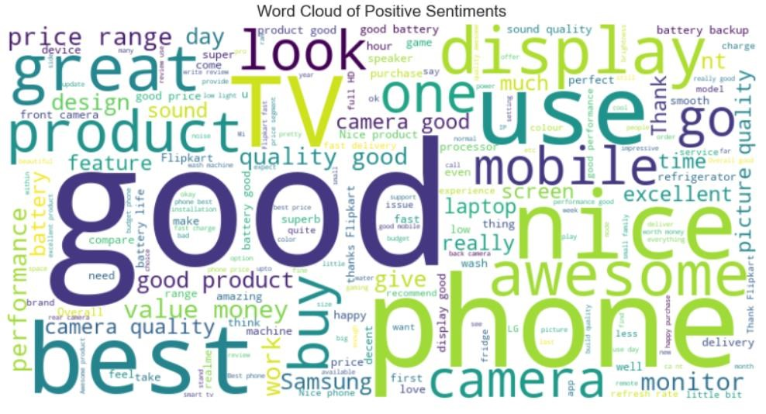

word cloud representing positive sentiments. In this visual representation, words associated with positive sentiments are depicted, with the size of each word proportional to its frequency or significance in the positive sentiment context.

**ALGORITHMS**

The following algorithms were applied for the project:

1. **Text Preprocessing**:
   * Text preprocessing techniques such as tokenization, part-of-speech (POS) tagging, lemmatization, punctuation removal, and stop word removal are employed to clean and prepare textual data for further analysis.

1. **Sentiment Analysis with TextBlob**:
   * TextBlob, a Python library for processing textual data, is utilized for sentiment analysis.
   * Sentiment analysis is performed by analyzing the polarity of text using TextBlob's pre-trained sentiment analysis model.
   * The sentiment polarity scores are categorized into three labels: Positive, Neutral, and Negative based on the polarity value.

1. **Linear Regression for Rating Prediction**:
   * Linear regression is employed to model the relationship between sentiment polarity scores and product ratings.
   * The sentiment polarity scores are used as features (independent variable), and the product ratings are treated as the target variable (dependent variable).
   * The model is trained using the least squares method to minimize the mean squared error (MSE) between predicted and actual ratings.

1. **Hyperparameter Tuning with Grid Search**:
   * Grid search with cross-validation is utilized to optimize the hyperparameters of the linear regression model.
   * The hyperparameters explored include whether to fit the intercept in the linear regression model.
   * Grid search helps to find the best combination of hyperparameters that minimizes the mean squared error (MSE) on the validation set.

1. **Pipeline with CountVectorizer and Linear Regression**:
   * A pipeline is constructed using CountVectorizer and Linear Regression for text feature extraction and modeling.
   * CountVectorizer is used to convert text data into numerical features by counting the frequency of words (unigrams and bigrams).
   * Linear Regression is applied to predict product ratings based on the extracted text features.
2. **Deep Learning Model with LSTM and CNN**:
   * A deep learning model architecture is designed using Long Short-Term Memory (LSTM) and Convolutional Neural Network (CNN) layers.
   * The LSTM layer captures sequential patterns in text data, while the CNN layer extracts local features.
   * The model is trained to classify sentiment into three categories: Positive, Neutral, and Negative.
   * The ensemble model combines the predictions of the LSTM and CNN models to enhance overall performance.

# CHALLENGES & OPPORTUNITY

**Challenges:**

1. **Finding Good Data**:
   * It can be hard to find lots of good examples of text with clear feelings (like happy, sad, or neutral) to teach computers how to understand feelings.
2. **Understanding Different Ways of Saying Things**:
   * People express feelings in many different ways, and computers might have trouble figuring out if someone is being sarcastic, joking, or serious.
3. **Making Computers Understand Negatives**:
   * Sometimes, when people say negative words like "not bad," they actually mean something positive. It's tricky for computers to catch these nuances.
4. **Making Sure Models Work Everywhere**:
   * Computers might work well in one situation (like analyzing movie reviews) but struggle in another (like understanding feedback about food).

**Opportunities:**

1. **Using New and Better Techniques**:
   * Scientists are always inventing better ways for computers to understand language, like using big, powerful models that learn from lots of text to get better at understanding feelings.
2. **Looking at More Than Just Words**:
   * We can teach computers to understand feelings better by also looking at pictures, sounds, or videos to see if they match the words people use.
3. **Making Computers Smarter for Specific Topics**:
   * We can teach computers to understand feelings better in specific areas, like healthcare or finance, by giving them lots of examples from those areas to learn from.
4. **Making Computers Explain Themselves**:
   * We can make computers better at telling us why they think something is happy or sad, so we can trust them more and understand their decisions.

# RISKS vs REWARDS

**Risks:**

1. **Misunderstanding the Sentiments**:
   * Risk: Sometimes, the computer might misunderstand how someone feels, leading to mistakes in understanding their message.
   * Impact: This could cause problems, like making wrong decisions based on the computer's misinterpretation of feelings.
2. **Getting Stuck on Training**:
   * Risk: The computer might get too focused on the examples it's been taught and struggle with new ones it hasn't seen before.
   * Impact: This could make the computer less useful in real-life situations where it needs to understand feelings it hasn't encountered before.
3. **Having Biased Data**:
   * Risk: The examples the computer learns from might favor certain opinions or groups over others.
   * Impact: This bias could make the computer give unfair or wrong answers, especially in important areas like hiring or loans.
4. **Making Things Too Complicated**:
   * Risk: Trying to make the computer understand feelings in very complicated ways might make it slow or hard to use.
   * Impact: This could make it tough to rely on the computer for understanding feelings, making it less helpful overall.

**Rewards:**

1. **Making Better Choices**:
   * Reward: If the computer can understand feelings well, it can help businesses make smarter decisions based on what people think and feel.
   * Impact: This could lead to better products, happier customers, and more successful businesses.
2. **Making Things Easier for People**:
   * Reward: By using sentiment analysis in apps and services, computers can better understand what people want and respond in ways that make them happy.
   * Impact: This could improve people's experiences with technology, making it more useful and enjoyable to use.
3. **Using Resources Wisely**:
   * Reward: Sentiment analysis can help companies figure out where to focus their efforts and money by spotting trends in what people are saying.
   * Impact: This could help companies avoid wasting time and money on things that aren't important to customers, making them more efficient and successful.
4. **Staying Ahead of the Game**:
   * Reward: Businesses that understand feelings well can adapt quickly to changes in what people want, giving them an edge over their competitors.
   * Impact: This could help businesses attract more customers, grow faster, and become leaders in their industries

# REFLECTION ON THE INTERNSHIP

1. **Learning Opportunity**:
   * The internship provided a valuable learning experience, allowing me to gain practical skills in natural language processing (NLP) and sentiment analysis.
   * Through tasks such as text preprocessing, sentiment labeling, and model evaluation, I deepened my understanding of NLP techniques and their applications.

1. **Hands-On Experience**:
   * Working on the code provided gave me hands-on experience with real-world datasets and machine learning models.
   * By applying algorithms like linear regression, grid search, and deep learning architectures, I gained practical insights into model development and evaluation.

1. **Challenges Faced**:
   * While working on sentiment analysis, I encountered challenges such as data preprocessing complexities, model selection dilemmas, and tuning hyperparameters effectively.
   * Overcoming these challenges required critical thinking, problem-solving skills, and iterative experimentation to find optimal solutions.

1. **Opportunities Explored**:
   * The internship presented opportunities to explore various approaches to sentiment analysis, including traditional machine learning methods and deep learning techniques.
   * Experimenting with different algorithms and models allowed me to understand their strengths, weaknesses, and suitability for different applications.

1. **Reflections on Sentiment Analysis**:
   * Sentiment analysis proved to be a powerful tool for extracting insights from text data, with applications ranging from customer feedback analysis to social media monitoring.
   * However, I learned that sentiment analysis is not without limitations, including the risk of misinterpretation, bias in training data, and the challenge of accurately capturing nuanced sentiments.

1. **Future Directions**:
   * Moving forward, I aim to further refine my skills in NLP and sentiment analysis by exploring advanced techniques such as transfer learning, contextual embeddings, and domain-specific sentiment analysis.
   * Additionally, I plan to deepen my understanding of model interpretability and ethical considerations in AI, ensuring responsible and equitable deployment of sentiment analysis technologies.

# RECOMMENDATIONS

Here are some recommendations for the project:

1. **Use Good Data**:
   * Make sure the data you use for training your sentiment analysis model is clean, accurate, and up-to-date.

1. **Understand Different Feelings**:
   * Try to understand not just whether something is positive, negative, or neutral, but also how strong those feelings are.

1. **Consider the Context**:
   * Think about the situation or topic being discussed in the text, as this can affect the sentiment. For example, "good" might mean something different in a movie review compared to a restaurant review.

1. **Look Beyond Just Words**:
   * Sometimes, pictures, sounds, or videos can also show how people feel. Try to combine these with the text to get a better understanding.

1. **Focus on Specific Details**:
   * Instead of just looking at overall sentiment, try to figure out how people feel about specific things mentioned in the text, like particular features of a product or service.

1. **Adapt to Different Areas**:
   * Make your sentiment analysis work well for different topics or industries by customizing it to understand the language used in those areas.

1. **Make it Easy to Understand**:
   * Help people understand why your sentiment analysis made a certain decision by explaining it in simple terms.
2. **Think About Fairness and Privacy**:
   * Make sure your sentiment analysis treats everyone fairly and respects people's privacy.

1. **Listen to Feedback**:
   * Keep improving your sentiment analysis by listening to what people say about it and using their suggestions to make it better.

1. **Work Together**:
   * Share your work with others and learn from them. By working together, we can make sentiment analysis more accurate and helpful for everyone.

# OUTCOME/CONCLUSIONS

The outcomes and conclusions are as follows:

1. **Regression Analysis:**
   * The linear regression model performed reasonably well in predicting ratings based on sentiment polarity, with a mean squared error (MSE) around 1.0146. Lower MSE values generally indicate better predictive performance, suggesting that the model's predictions are relatively accurate.

1. **Hyperparameters:**
   * Through grid search cross-validation, the best hyperparameters for the linear regression model were determined to be fitting the intercept (fit_intercept: True). This choice led to the best model with an MSE of 1.0146, indicating that including the intercept improved the model's predictive performance.

1. **Applying Multiple Hyperparameters for Best Configuration:**
   * Among different hyperparameters explored, fitting the intercept (fit_intercept: True) yielded the best model with the lowest MSE of approximately 1.0146. This further confirmed the importance of including the intercept for better model performance.

1. **N-Grams:**
   * Incorporating both unigrams and bigrams into the linear regression model's feature extraction process resulted in an improved predictive performance, as indicated by a lower MSE of approximately 0.721. This suggests that considering n-grams enhanced the model's ability to predict ratings from review text.

1. **Deep Learning Model:**
   * The deep learning model for sentiment analysis achieved high accuracy in classifying sentiments into Positive, Neutral, and Negative categories. With approximately 97.40% test accuracy, the model demonstrated effectiveness in detecting and segmenting sentiments from textual data.

1. **Using LSTM and CNN for Fine Tuning:**
   * The ensemble model combining LSTM and CNN architectures did not significantly improve accuracy compared to individual models. Despite consistent training and validation accuracy around 89%, the ensemble model's test accuracy remained similar at approximately 89.37%. Further experimentation and refinement may be necessary to enhance its performance.

# ENHANCEMENT SCOPE

1. **Feature Engineering:** Explore additional features like review length and emoticons.
2. **Advanced Text Preprocessing:** Implement spell checking and handle contractions.
3. **Fine-Tuning Hyperparameters:** Optimize parameters like learning rate and batch size.
4. **Ensemble Learning:** Combine predictions from multiple models for better accuracy.
5. **Transfer Learning:** Adapt pre-trained models like BERT for sentiment analysis.
6. **Domain-Specific Customization:** Customize models for specific industries or domains.
7. **Interactive Visualization:** Develop tools for intuitive exploration of sentiment analysis results.
8. **Continuous Monitoring:** Gather feedback for ongoing improvement of the system.

# LINK TO THE EXECUTABLE FILE

**Repository Link:**

# RESEARCH QUESTIONS AND RESPONSES

**Question:** How does sentiment analysis contribute to understanding customer feedback in the e-commerce industry?

**Responses:**

1. Sentiment analysis helps e-commerce businesses gain insights into customer opinions and emotions expressed in product reviews, allowing them to identify trends, strengths, and areas for improvement.
2. By analyzing sentiment, e-commerce companies can gauge customer satisfaction levels, identify common pain points, and tailor their products and services to meet customer expectations more effectively.
3. Sentiment analysis enables e-commerce platforms to automate the process of sorting and categorizing large volumes of customer feedback, making it easier to prioritize and address urgent issues.
4. Understanding sentiment in reviews allows e-commerce businesses to monitor brand reputation and identify potential PR crises before they escalate, enabling proactive reputation management strategies.
5. Sentiment analysis can also be used to personalize customer experiences by identifying individual preferences and tailoring recommendations and marketing messages accordingly.